CHAPTER 1

INTRODUCTION

1.1 Introduction
In today’s rapidly evolving digital environment, the need for efficient and reliable management systems has become essential across all sectors. Traditional manual systems for maintaining records are time-consuming, error-prone, and difficult to manage as data volume increases. With advancements in computer technology, organizations are shifting toward automated systems to improve productivity, accuracy, and accessibility of information.
The Service Management System is a computer-based application developed using the C programming language and integrated with HTML, CSS, and JavaScript for browser-based interaction. This project focuses on managing service records such as service ID, owner name, service type, bill amount, and service status. It is designed mainly for academic and small-scale service centre usage.
The project highlights the integration of a low-level programming language (C) with web technologies to provide both command-line functionality and graphical representation. This dual-interface approach enhances usability while maintaining simplicity.

1.2 Purpose of the Application
The primary purpose of this application is to automate the process of managing service records efficiently. The system aims to eliminate manual paperwork and provide a centralized platform for adding, viewing, and updating service details.
The application is intended to
- Reduce human errors in record maintenance
- Save time in searching and updating service information
- Provide a clear visual representation of service status
- Demonstrate real-time interaction between C programs and web browsers
This system is particularly useful for educational institutions, workshops, and small service centres where a lightweight and easy-to-use solution is required.

1.3 Featuresq
The Service Management System includes the following features
- Secure login authentication using HTML and JavaScript
- Menu-driven console interface
- Add new service records
- Automatic bill calculation based on service type
- Dynamic generation of HTML pages
- Color-coded service status display in browser
- Update service status (Pending, In Progress, Completed)
- Cross-platform browser opening support

1.4 Objective
The main objectives of this project are
- To design a simple service management application using C
- To implement structured data handling using structures and arrays
- To integrate C programming with HTML and CSS
- To enhance learning of system calls and file handling
- To provide a real-world application-based learning experience

CHAPTER 2

LITERATURE SURVEY
2.1 Digital Transformation: "Recent studies highlight a shift from manual, paper-based record-keeping to centralized digital platforms, which have been shown to reduce customer wait times by up to 30–40% through automated scheduling and real-time status tracking."
2.2 Emerging Technology: "Modern research emphasizes the integration of AI-driven predictive maintenance and IoT-enabled diagnostics to move beyond simple appointment booking toward proactive vehicle health monitoring and optimized resource allocation."
Sl. No | Title / Study Area and Year | Technology | Key Features | Limitations | Relevance to BIKECHOICE
1 | Digital Bike Service Portals (2022) | Web technologies (HTML, CSS, JS, Database) | Provides service booking, live status, and bill generation. | High complexity, requires internet and heavy server support. | BIKECHOICE simplifies this by simulating the service flow without needing a database.
2 | Garage Management Decision Systems (2024) | Web applications with backend logic | Automates job card creation and service type categorization. | High implementation cost and advanced framework needs. | BIKECHOICE adopts service logic (General/Oil/Full) in a simpler, faster C-based manner.
3 | Console-Based Workshop Apps (2023) | C Programming Language | Menu-driven programs for bike and owner entry. | Lack of visual interface and poor user interaction. | BIKECHOICE enhances this by integrating a styled browser-based output.
4 | Academic Mini Projects on Workshop Automation (2021) | C with file handling and system calls | Demonstrates integration between programs and local files. | Mostly static output with very limited user interactivity. | BIKECHOICE adds dynamic HTML generation and automated browser interaction.

CHAPTER 3

SYSTEM REQUIREMENTS

3.1 Software Requirement
The following software requirements are needed to run the system
Component | Specification
Operating System | Windows 7 ,i3
Compiler | GCC 12
Web Browser | Google Chrome 145.0.7
Text Editor or IDE | VS Code 1.109.5

3.2 Non-Functional Requirement

Non-functional requirements define system qualities

Component | Specification
Performance | Fast execution
Usability | Simple and user-friendly interface
Reliability | Accurate data handling
Portability | Works on multiple operating

3.3 Functional Requirement
Functional requirements define what the system should do
- The system shall allow only authorized users to log in
- The system shall allow adding new service records
- The system shall display all services in a browser
- The system shall update service status

CHAPTER 4

SYSTEM DESIGN

4.1 Flow-Chart
The flowchart represents the logical flow of the application from login to exit. It shows decision-making steps such as login validation, menu selection, and status updates.
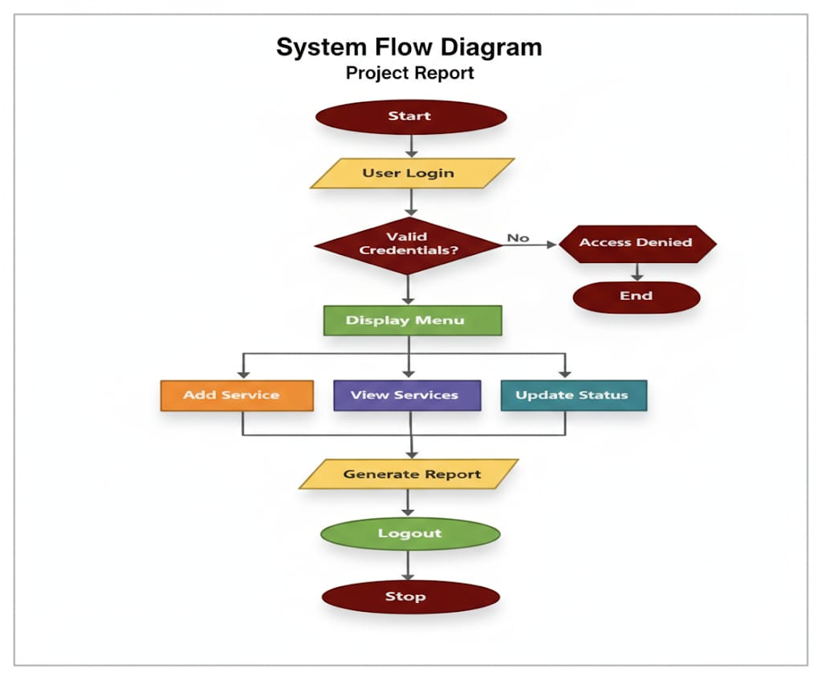
Figure 4.1: Flow chart

4.2 Sequence Diagram
The sequence diagram illustrates the interaction between the user, the C program, and the browser during system execution.
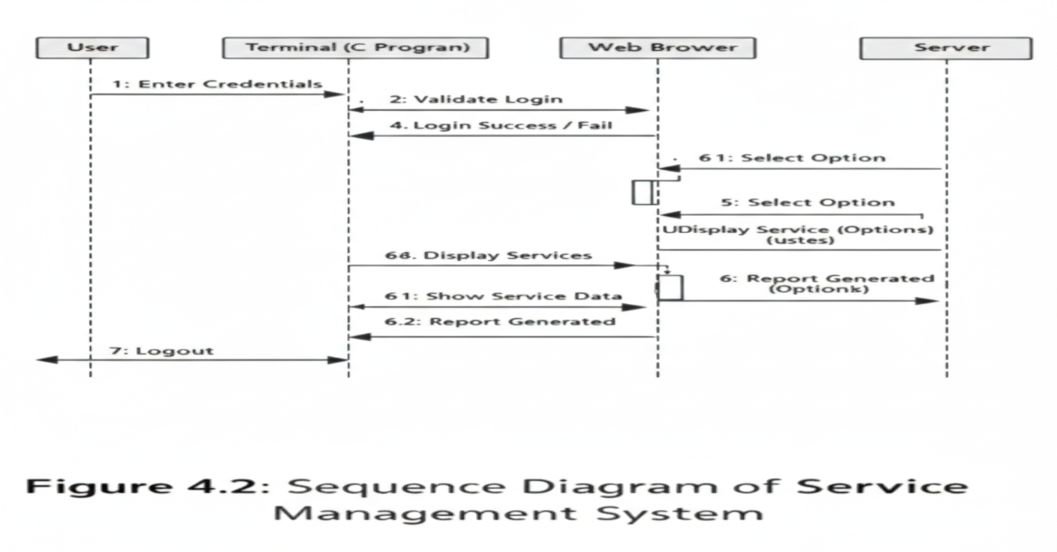

4.3 Data Flow Diagram
The Data Flow Diagram (DFD) shows how data flows within the system, including input, processing, and output stages.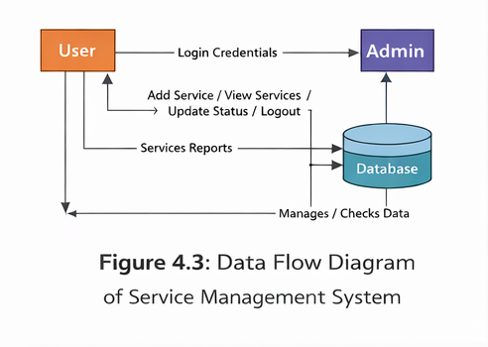

4.4 Activity Diagram
The activity diagram describes the workflow of service management from start to finish. 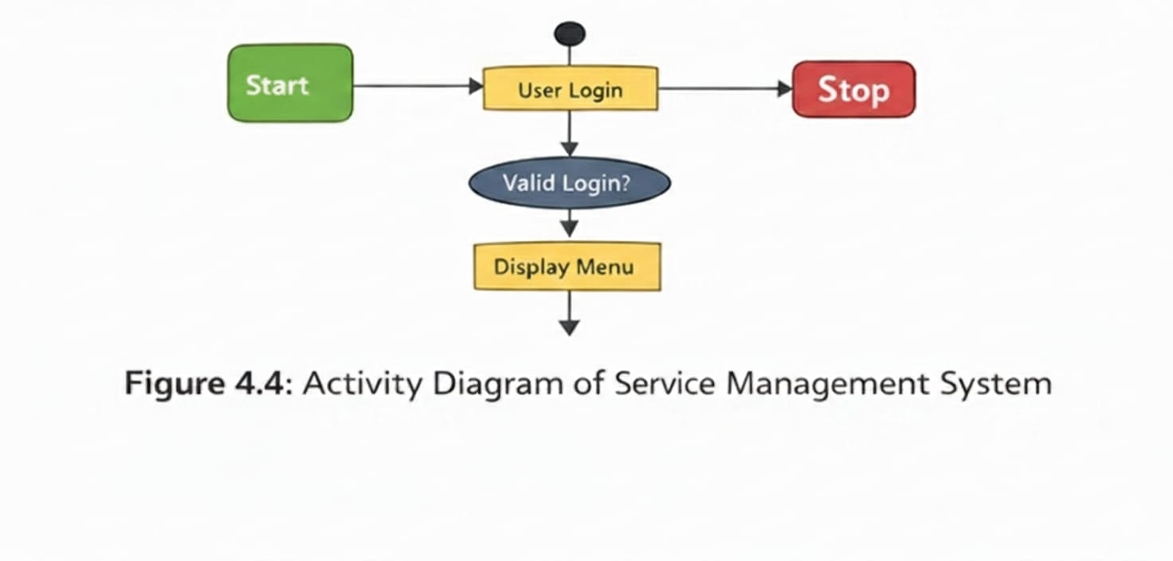

CHAPTER 5

IMPLEMENTATION

5.1 C Code
The C code includes structure definitions, menu-driven logic, file handling, and system calls to generate and open HTML files dynamically.
BIKECHOICE C CODE
#include <stdio.h>
#include <stdlib.h>
#include <string.h>
#ifdef _WIN32
#include <windows.h>
#endif
/* ================= DATA ================= */
struct Service {
int id;
char owner[30];
char service[20];
int bill;
char status[20];
};
struct Service s[50];
int count = 0;
/* ================= OPEN HTML ================= */
void openHTML(const char *file) {
#ifdef _WIN32
char cmd[200];
sprintf(cmd, "start %s", file);
#else
char cmd[200];
sprintf(cmd, "xdg-open %s", file);
#endif
system(cmd);
}
/* ================= LOGIN PAGE ================= */
void loginPage() {
FILE *fp = fopen("login.html", "w");
fprintf(fp,
"<!DOCTYPE html>\n"
"<html lang='en'>\n"
"<head>\n"
"<meta charset='UTF-8'>\n"
"<title>Login</title>\n"
"<style>\n"
"body{margin:0;height:100vh;display:flex;align-items:center;justify-content:center;"
"background:#020617;font-family:Arial;color:white}\n"
".box{background:rgba(255,255,255,0.08);padding:30px;border-radius:20px;width:360px}\n"
"input{width:100%%;padding:12px;margin:10px 0;border:none;border-radius:10px;"
"background:#111827;color:white}\n"
"button{width:100%%;padding:12px;border:none;border-radius:10px;"
"background:linear-gradient(90deg,#38bdf8,#a855f7);color:white;font-weight:bold}\n"
"</style>\n"
"</head>\n"
"<body>\n"
"<div class='box'>\n"
"<h2 style='text-align:center'>Service Login</h2>\n"
"<form onsubmit='return loginCheck()'>\n"
"<input type='text' id='user' placeholder='Username' required>\n"
"<input type='email' id='mail' placeholder='Email' required>\n"
"<input type='password' id='pass' placeholder='Password' required>\n"
"<button type='submit'>Login</button>\n"
"</form>\n"
"<p style='font-size:12px;text-align:center'>admin | admin@gmail.com | 123456</p>\n"
"</div>\n"
"<script>\n"
"function loginCheck(){\n"
" var u = document.getElementById('user').value.trim();\n"
" var e = document.getElementById('mail').value.trim();\n"
" var p = document.getElementById('pass').value.trim();\n"
" if(u === 'admin' && e === 'admin@gmail.com' && p === '123456'){\n"
" document.body.innerHTML = '<h1 style=\"text-align:center;margin-top:40vh;color:#22c55e\">Login Successful ✅<br><small>Return to terminal and press ENTER</small></h1>';\n"
" } else {\n"
" alert('Invalid Credentials');\n"
" }\n"
" return false;\n"
"}\n"
"</script>\n"
"</body>\n"
"</html>"
);
fclose(fp);
openHTML("login.html");
printf("\n✔ Login page opened in browser\n");
printf("✔ After SUCCESSFUL login, press ENTER here\n");
getchar();
}
/* ================= ADD SERVICE ================= */
void addService() {
printf("Service ID: ");
scanf("%d",&s[count].id);
printf("Owner Name: ");
scanf("%s",s[count].owner);
int c;
printf("1.General 2.Oil 3.Full : ");
scanf("%d",&c);
if(c==1){ strcpy(s[count].service,"General"); s[count].bill=500; }
if(c==2){ strcpy(s[count].service,"Oil"); s[count].bill=300; }
if(c==3){ strcpy(s[count].service,"Full"); s[count].bill=1000; }
strcpy(s[count].status,"Pending");
count++;
}/* ================= VIEW SERVICES IN BROWSER ================= */
void viewServicesHTML() {
FILE *fp = fopen("services.html", "w");
fprintf(fp,
"<!DOCTYPE html>\n<html lang='en'>\n<head>\n<meta charset='UTF-8'>\n"
"<title>All Services</title>\n<style>"
"body{font-family:Arial;text-align:center;background:#f0f4f8;}"
"h2{color:#1e3a8a;margin-top:20px;}"
"table{border-collapse:collapse;width:80%%;margin:auto;}"
"th,td{border:1px solid #000;padding:10px;text-align:center;}"
"th{background-color:#4ade80;color:white;}"
"tr:nth-child(even){background-color:#e2e8f0;}"
".Pending{background-color:#fde68a;}" // Yellow
".InProgress{background-color:#60a5fa;}" // Blue
".Completed{background-color:#22c55e;color:white;}" // Green
"</style>\n</head>\n<body>\n"
"<h2>All Services</h2>\n"
"<table>\n<tr><th>ID</th><th>Owner</th><th>Service</th><th>Bill</th><th>Status</th></tr>\n"
);
for(int i=0; i<count; i++) {
fprintf(fp,
"<tr class='%s'><td>%d</td><td>%s</td><td>%s</td><td>%d</td><td>%s</td></tr>\n",
s[i].status, s[i].id, s[i].owner, s[i].service, s[i].bill, s[i].status
);
}
fprintf(fp, "</table>\n</body>\n</html>");
fclose(fp);
openHTML("services.html"); // Opens in browser
}
/* ================= UPDATE STATUS ================= */
void updateStatus() {
int id;
printf("Enter Service ID: ");
scanf("%d",&id);
for(int i=0;i<count;i++){
if(s[i].id==id){
int c;
printf("1.Pending 2.InProgress 3.Completed : ");
scanf("%d",&c);
if(c==1) strcpy(s[i].status,"Pending");
if(c==2) strcpy(s[i].status,"InProgress");
if(c==3) strcpy(s[i].status,"Completed");
return }
}
printf("Service not found\n");
}
/* ================= MAIN ================= */
int main() {
int ch;
loginPage(); // LOGIN FIRST
do {
printf("\n1.Add Service\n2.View Services (Browser)\n3.Update Status\n4.Exit\nChoice: ");
scanf("%d",&ch);
if(ch==1) addService();
if(ch==2) viewServicesHTML();
if(ch==3) updateStatus();
} while(ch!=4);
return 0;}

CHAPTER 6

SNAPSHOTS

Login page
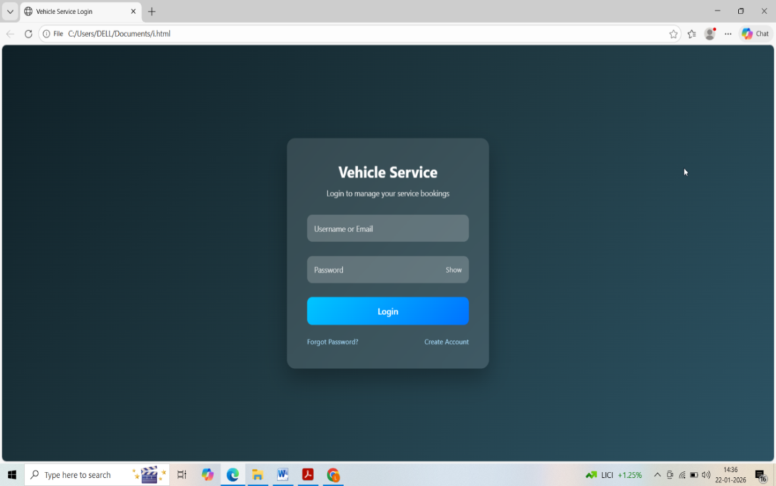
Figure 6.1: Login Page for users
- Login Successful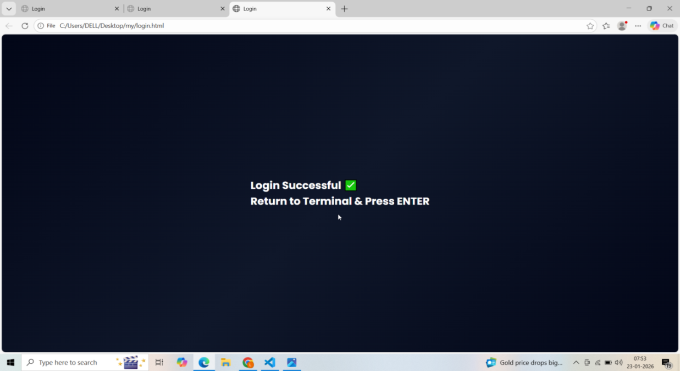
Figure 6.2: Login Successful Login Screen of user

- Add Service Output
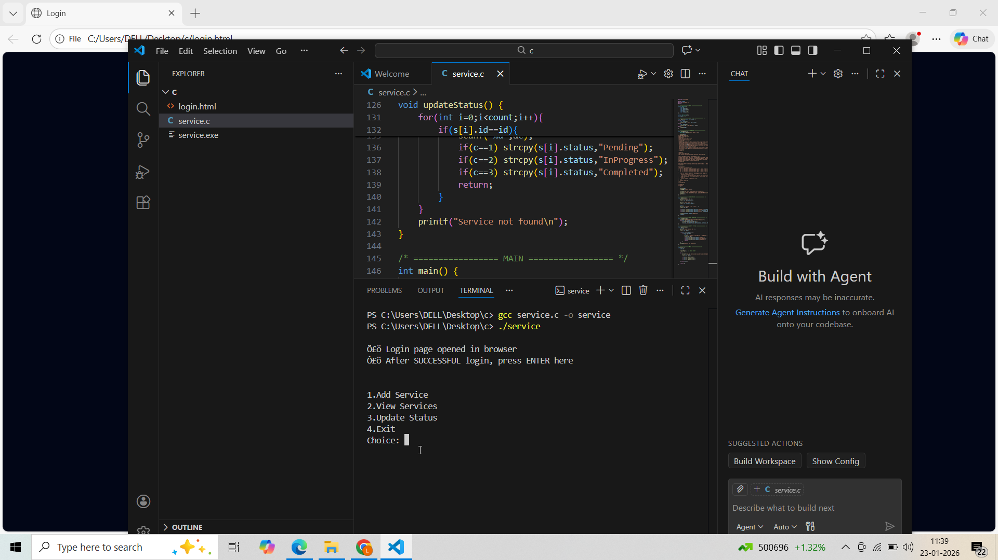
Figure 6.3: Add Service Output for users

- Service Table in Browser
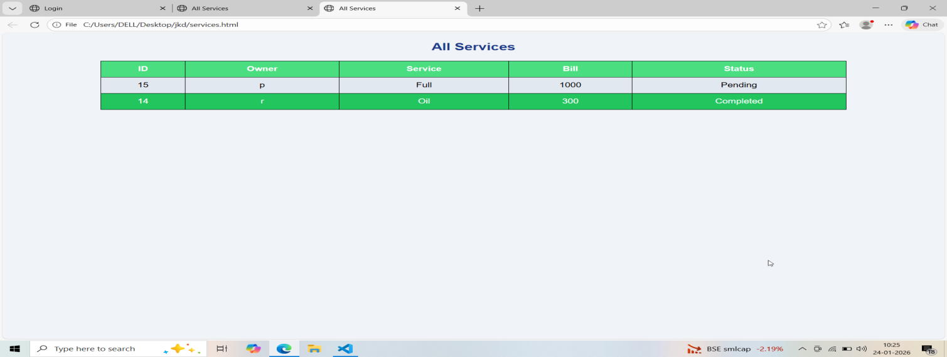
Figure 6.4: Service Table in Browser of user

CHAPTER 7

CONCLUSION

The Service Management System successfully demonstrates how C programming can be integrated with web technologies to build an efficient and user-friendly application. The project fulfills all stated objectives and provides a strong foundation for future enhancements. It also highlights the importance of structured programming, file handling, and dynamic HTML generation in real-world scenarios. Moreover, the system can be extended with database connectivity and multi-user support to increase its practical applicability. Overall, this project serves as a valuable learning tool for understanding the integration of traditional programming with modern web interfaces.

REFERENCES
- Dennis Ritchie – The C Programming Language
- W3Schools – HTML, CSS, JavaScript Documentation -https://www.w3schools.com
- GeeksforGeeks – C Programming Tutorials -https://www.mindluster.com/lesson/23000-video?utm_source=chatgpt.com

